**Thermodynamics Experiment no.1**

**What is a lay out?**

The process of setting out material on a page.

**OR**

The way in which text or pictures are set out on a page.

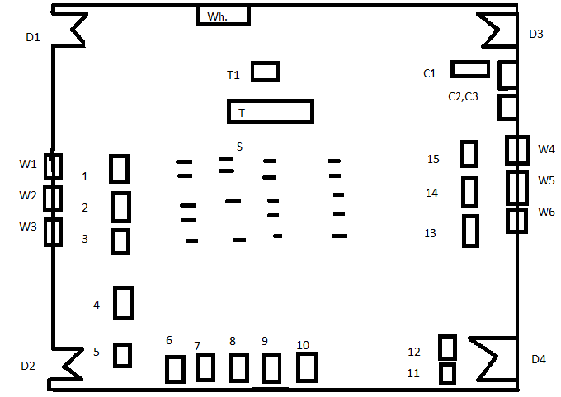**Representation:**

D1=Door 1

D2=Door 2

D3=Door 3

D4=Door 4

W1=Window 1

W2=Window 2

W3=Window 3

W4=Window

W5=Window

W6=Window

W h=White board

T1=Chair

T=Table

C1=Cupboard

C2=Cupboard

C3=Cupboard

S=Stools

**Equipments:**

**1)**

**1.1.Two stroke petrol engine demonstration unit:**

As the name implies, the **two stroke engine** only requires two piston movements (one cycle) in order to generate power. The engine is able do produce power after one cycle because the exhaust and intake of the gas occurs simultaneously. There is a valve for the intake stroke that opens and closes due to changing pressures. In addition, due to its frequent contact with moving components, the fuel is mixed with oil to add lubrication, allowing smoother strokes.

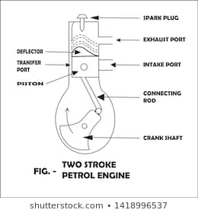

**1.2.Four stroke single cylinder diesel engine model (IPC-9200-D6):**

A four-stroke diesel engine resembles a gasoline engine as it works on the four-stroke cycle, that is: induction, compression, power and exhaust. When the piston gets down on the air admission stroke, the lower pressure in the cylinder allows a charge of air into the cylinder through the inlet valve which opens just before top dead centre.

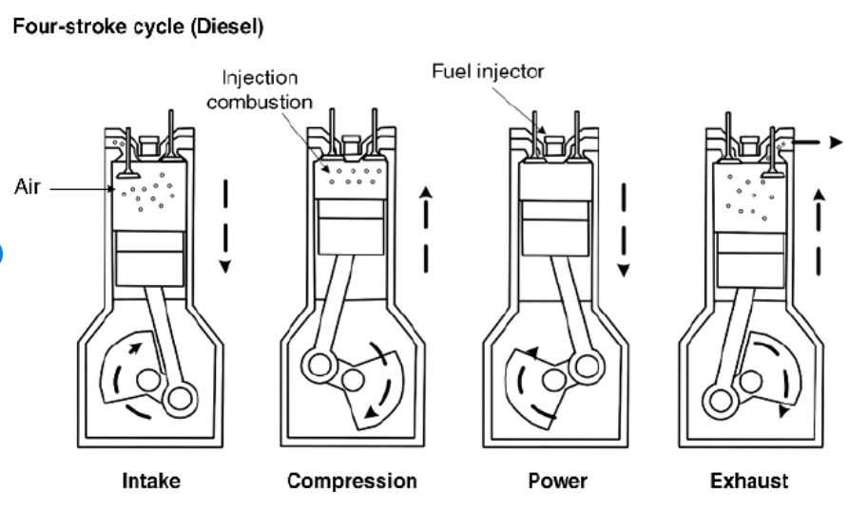

**2.Rankin cycle steam turbine (S220/03764):**

The Rankine cycle is the fundamental operating cycle of all power plants where an operating fluid is continuously evaporated and condensed. The selection of operating fluid depends mainly on the available temperature range..

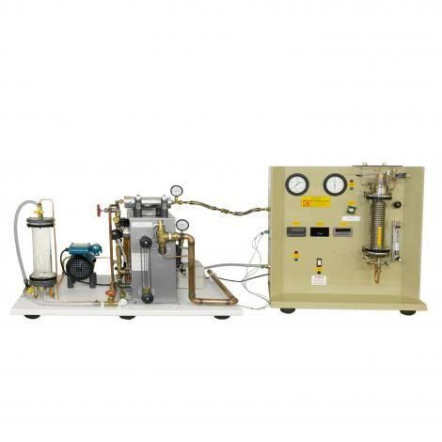

3.Compressible flow range (F 300):

Compressible flow (or gas dynamics) is the branch of fluid dynamics that deals with flows having significant changes in fluid density .The study of compressible flow is relevant to high speed air craft, jet engines.

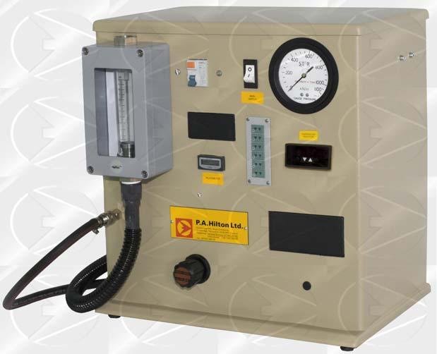

**3.1.Nozzle performance (F 300):**

A series performance of convergent and convergent-divergent nozzle may be installed in one of two locations in a high pressure measuring chamber.

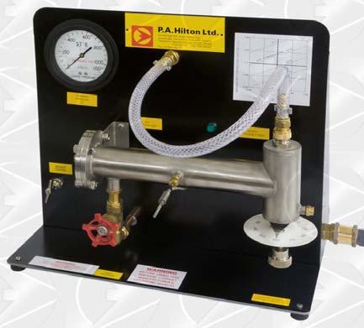

**4.Radiation heat transfer unit (TE6/EV):**

Radiation heat transfer is the process in which the thermal energy is exchanged b/w two surfaces by obeying the laws of electromagnetic.

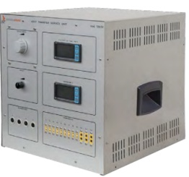

**5.Boiling heat transfer module (H1/25):**

The formation of steam bubbles along a heat transfer surface has a significant effect on the overall heat transfer rate.

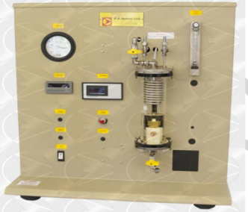

**6.Flow boiling demonstration (H 411):**

Hilton **Flow Boiling Demonstration** Unit has been produced to provide students with a clear visual demonstration of what is happening inside the generating tubes of partical plants.

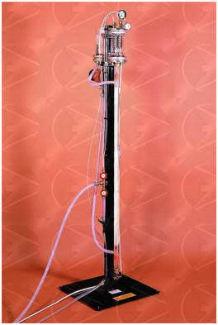

**7.Concentric tube heat exchanger:**

 This is the simplest of the optional **heat exchangers**. It has two **tubes**, one inside the other. One **tube** carries hot fluid, the other carries cold fluid. **Heat** transfers between them.

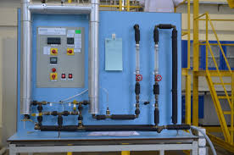

8)

**8.1.Linear heat conduction experiment (TD 1002 A):**

This experiment has a solid brass disc with an electric heater (heat source) at its centre and a circular cross section cooling tube (heat sink) around its circumference. It mounts on a base plate with a clear schematic of the experiment layout.

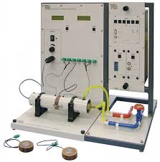

**8.2.Absorption refrigeration (816/012950):**

It is a refrigerator that uses heat sources (e .g solar energy) to provide the energy that needed to derive the cooling process.

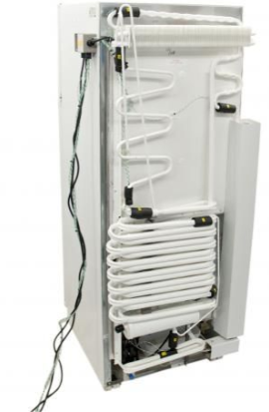

**9.Heat pump trainer (BPC/EV):**

The purpose of a heat pump is to supply heat to a region by taking heat from a lower temperature region.

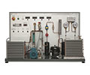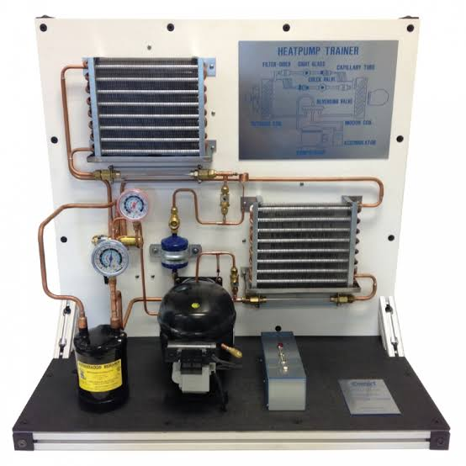

**10)**

**10.1.Thermo electric heat pump trainer (R 534):**

The Hilton **Thermo**-**Electric Heat Pump** has been designed to enable students to investigate the performance of a semi-conductor module which, on the application of an **electrical** power supply, will produce a refrigerating effect.

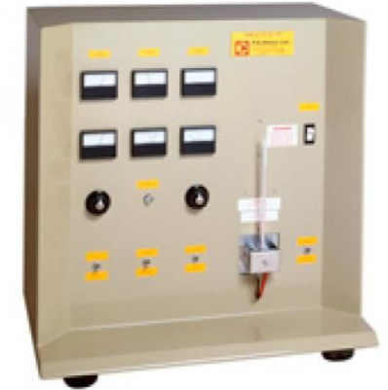

supply will produce a refrigerating effect.

**10.2.Vortex tube refrigerator (R 434/07043):**

The vortex tube is an interesting tube in which a compressed gas is divided into two streams at low pressure. It is an unusual process for producing cooling air.

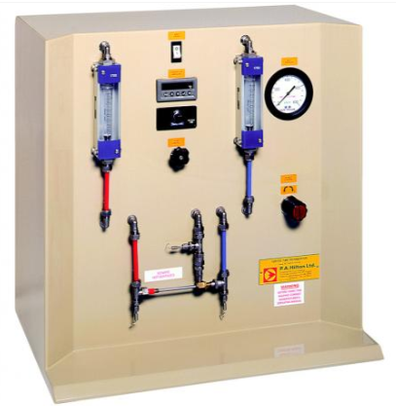

**11.Commercial refrigerator trainer (IPC-2007-1):**

The comprehensive refrigerator trainer is designed for comprehensive and advanced work studies involving industrial and commercial refrigeration system.

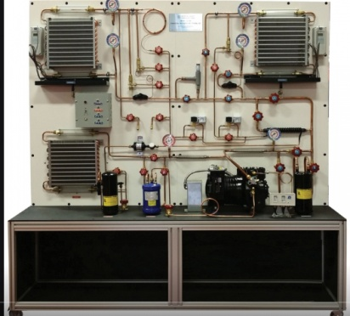

**12.Mechanical heat pump trainer:**

Heat Pump is a device to pump heat from one source to another.

The heat obtained by heat pump is more than that could be obtained by direct electrical heating.

The apparatus consists of refrigeration system with water cooled shell and coil type evaporator and condenser.

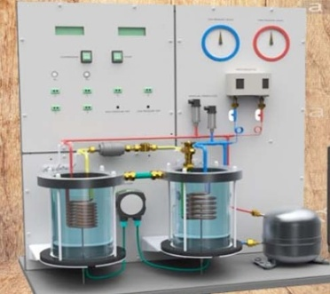

**13.Laboratoryier conditioning trainer (IPC-512-RAC):**

A complete instrumented air conditioning unit mounted on a steel framed caster wheels.

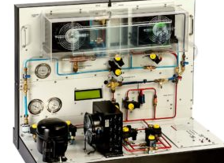

**14.Cooling tower trainer (RAD-CTS-3):**

In wet cooling towers the water is to be cooled is sprayed over a wet deck surface, Water and air come into direct contact in a counter flow.

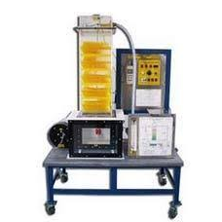  
**15.Nozzle pressure distribution**:

The nozzle pressure unit allows investigate the pressure distribution and the mass flow rate.

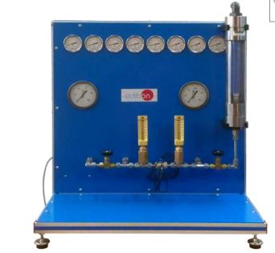

**Conclusion:**

In this lab we have learn about Layout.With the help of Layout we can locate the apparatus in the lab.